Closing Process Guide and Outline

Identifying Grants to Close
You will utilize the Expired Report to identify what grants need to be closed out. On the fifth day of each month the Expired report is generated and delivered via e-mail. Verify if the grant is expected to be extended or receive additional funding.

Prioritizing – What/When?
Once closing status has been confirmed, the list of expired grants can be entered in Cognos to generate the closing checklists. Scrubbings are put in order based on closeout due date which can vary anywhere from 15 days up to 120 days for closeout. Scrubbing is the closing process done through the Checklist. Federal awards are to be closed either 120 days after expiration date unless otherwise stated in the agreement.
The closeout scrub should be completed so that the closing e-mail notifications are sent to the responsible cost center at the grant level 15-45 days after expiration (based on due date of final financial/invoice).
The closing checklist is obtained through Cognos, ensuring the most updated version is being used and this report pulls in the transaction details that you will review. Using a checklist is an audit requirement.
Path in Cognos: Team Content > Departmental Content > Treasurer > SPS > Post Award
https://reporting.itap.purdue.edu/bi/?pathRef=.public_folders%2FDepartmental%2BContent%2FTreasurer%2FSPS%2FPost%2BAward%2FPost%2BAward%2BClosing

Closing Checklist
Section A - To be completed prior to contacting Business Office

Does Grant Status = Award/Expired? - Verify that grant status flipped to Expired. If the status is still Approved Award, change to Expired. This will prevent new commitments from being placed on the grant.
Review FSSR’s –Review FSSR’s for the month of expiration and the month in which the account is being closed.
Compare Sponsor Award Budget to SAP Budget
- Does the grant value match the award documentation?
- Do the budget line items match the proposed/sponsor award budget line items?
  - If it doesn’t match, does it match sponsor approved rebudget?

Check Budget -Confirm budget validity end date is extended out 1 year past expiration to allow for closeout/correction entries to post.
Cost Sharing: If an account has a balance, the type of cost share commitment should be reviewed in order to take appropriate action.
Check Cost Sharing Requirement
- Specific dollar amount?
  - This dollar amount must be met. The department needs to discuss the situation with the PI and SPS. There may be situations where a specific item (equipment, supplies, etc) was not purchased or the cost was less than budgeted. Exceptions will be reviewed by SPS on a case-by-case basis.
- Percent of sponsor dollars awarded (one-to-one match, 25% of sponsor budget)?
  - Balance is acceptable as long as the commitment has been met.
- Percent of effort for an individual?
  - Balance is acceptable as long as the commitment has been met.
- Was it expensed as proposed?
- Cost share must be zero at closing

Contributed F&A (IDC)
- Contributed F&A should be checked to ensure it calculated properly. Check cost share commitment tab for verification.

Memo Match – departments are expected to send documentation of the memo match that benefited to SPS within 60 days after expiration.
- Do we have proof that the memo match has been met? This must be detailed/quantified what benefited the project.
  - Equipment from third party -> Gift and loan report from third party
  - SPS external account (state, industrial, PU/PRF fellowship/assistantship) -> AIMS/Line-Item Display/FSSR
  - Other -> Letter from Donor/Company
  - Subcontract cost share documented on invoices (SPS gathers this information)
- Work with the Business Office to obtain information, if necessary
- PI needs to certify that the match benefited the project.

GR55
Check GR55 –Run t-code GR55, use report group z500
Cash Balance, Other Assets (AR), and Liabilities should be zero
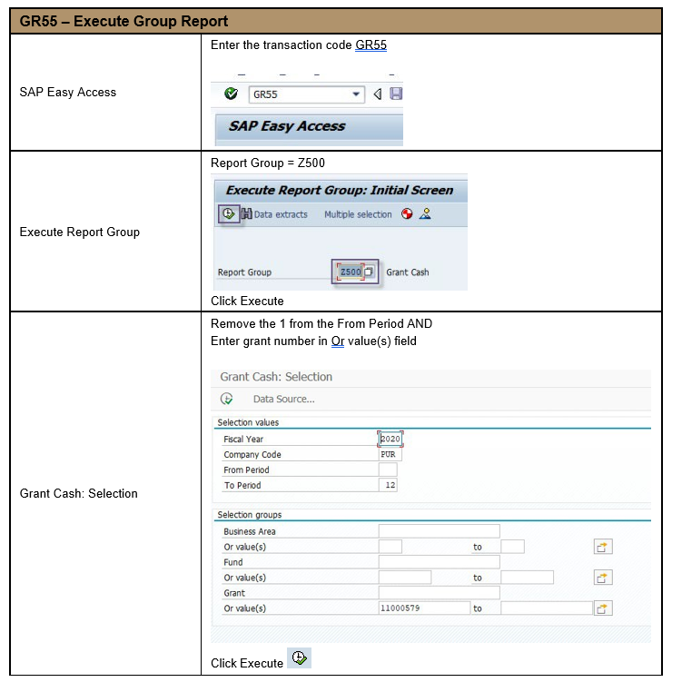

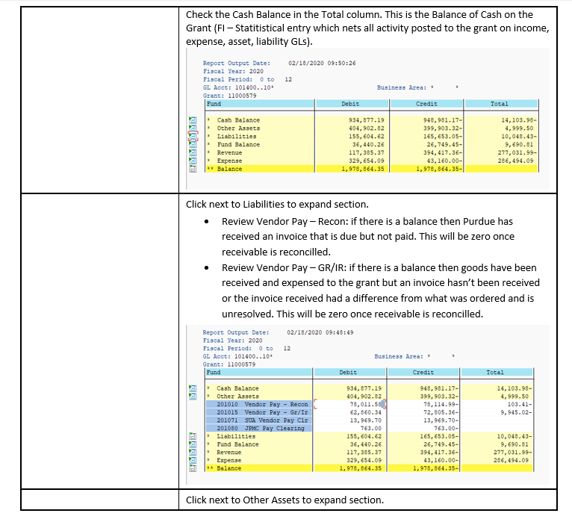

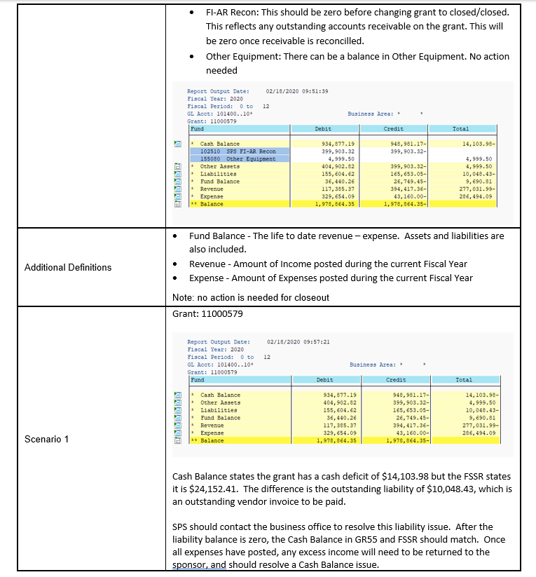

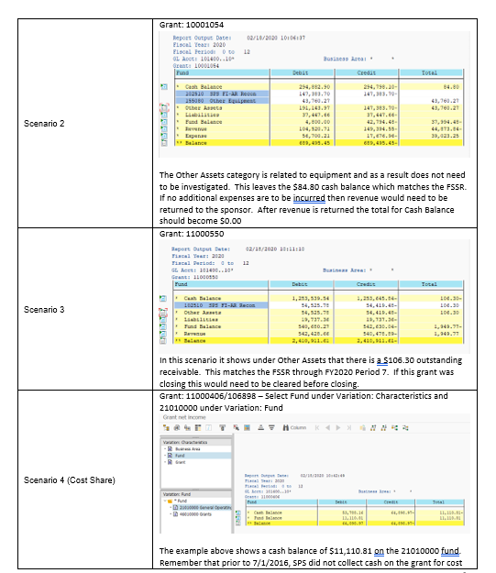

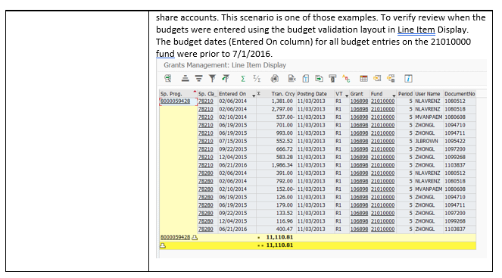
Check Questionable Transactions - Run QTR report to check questionable transactions – BI (Cognos) - ‎> Boiler Insight ‎> Departmental Content ‎> West Lafayette ‎> Office of the Treasurer (formerly Business Services) ‎> SPS ‎> Post Award
- Review charges for approvals and/or allowability
- QTR – SPS Guidance
https://www.purdue.edu/business/sps/pdf/Questionable_Transaction_Report_Process.pdf
Check Regulatory - Run BI – Cognos report ‎> Boiler Insight ‎> Departmental Content ‎> West Lafayette ‎> Office of the Treasurer (formerly Business Services) ‎> SPS ‎> Post Award
*If expenses posted to any of the above ensure proper regulatory approvals were in place.
Participant Support Costs
- Ensure participant support is expended appropriately.
- Obtain confirmation from BO that all charges posted to the Participant Support account were truly for Participant Support
- Guidelines for Participant Support Costs
https://www.purdue.edu/business/sps/pdf/Participant_Support_vs_Human_Incentives.pdf
Check Pre-Award Charges
- Are Pre-Award charges allowable?
- Run a Payroll Transaction Report to confirm salary dates
- If project start date is after 1st of month, confirm with BO that salaries were pro-rated

Review Charges 90 days prior to Expiration – things to consider:
- What is the project?
- What items were purchased?
  - Type/Volume/Amount?

Check Post-Expiration Charges
- Are the post-expiration charges allowable? Look at documents in Perceptive Content (WebNow) to confirm dates. Run a Payroll Transaction Report in COGNOS to check salary dates
- If project end date is before last day of month, confirm with BO that salaries were pro-rated
- Have business office confirm any charges you are unable to confirm

Commitments/Reservations
- Run line-item display (T-Code S_PLN_16000269), choose layout /COMMRESPRK (Commitments/Reservations/Parked Documents). If a balance appears, there is a commitment on the account.
- Include as part of final expenses or not? Verify with BO

Check Foreign Travel – if applicable
- Is foreign travel allowable? If not do we have documented approval?
- For converted grants you will need to run line-item display (T-Code S_PLN_16000269), choose layout /Foreign Trv (Foreign Travel/SPS) on the old grant to see if any charges posted to a foreign travel GL prior to 7/1/18.

Check for Admin & Clerical salaries (Federal & Federal pass-thru)
If admin or clerical salaries were charged, are unlike circumstances documented?
- Guidance for checking Administrative & Clerical salaries
https://www.purdue.edu/business/sps/doc/AdminClericalSalaryCheck-updated%20May2019.docx

Clerical Salaries – roll up into sponsored class 78240. If any charges appear on the FSSR in this sponsored class, review the grant agreement and budget to see if unlike circumstances were documented. If documentation cannot be located, ask the Business Office to provide documentation as part of the closing email.
Administrative Salaries – roll up into sponsored class 78210. If any charges appear on the FSSR in this sponsored class, further investigation is required. Run BI – Cognos report Boiler Insight ‎> Standard Content ‎> HR and Payroll ‎> Statement of Payroll Charges

Asset Summary
Verify equipment purchased on grant. Who has rightful claim to the equipment? (retain title) If it is sponsor owned, is the department aware?
Check F&A (IDC)
- Did F&A calculate properly?
Select correct layout in Line-item display determined by the applicable F&A base to verify F&A calculations.
Subcontract Accounts
- Have we received a final invoice from the subcontractor? (check subrecipient calculator, final closing checklist uploaded into Perceptive by Subaward Team)
- Has the subcontractor submitted any other required reports? (verify on the sub closing checklist uploaded to Perceptive)
- Has the subcontractor’s cost share requirement been met (if applicable)?
- Have all payments and final invoice from the subcontractor been processed? If not, be sure to include this amount in the final request for payment. (Ensure when sub calculator is reviewed that the upper section “expense amount” matches to the total of the Standard Cost Table. If not, this may indicate an invoice in process that has not posted to the grant. See below screenshot for an example of when this might happen).

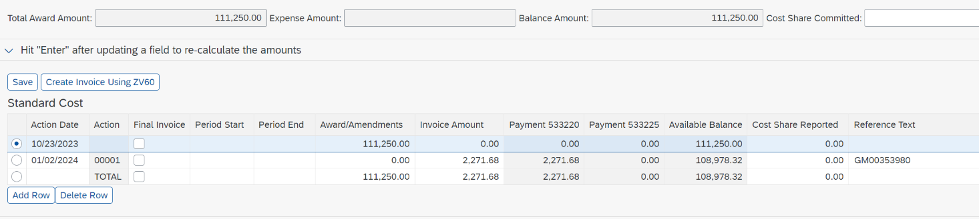

NSF 2 Months Rule (if applicable)
- Check that senior personnel have not exceeded 2 months. If so, follow the NSF guidance found here: https://www.purdue.edu/business/sps/pdf/NSF_2_Months_Rule_Handbook.pdf . If necessary, confirm senior personnel by running a Payroll Transaction Report
NIH Salary Cap (if applicable)
- Confirm, based on grant number, all individuals who have exceeded the applicable salary cap limitations are in compliance. Verify for both ELI and ELII accounts.

Revenue GL’s

  - Confirm there are no balances on revenue GL’s (begins with a 4) other than 415000. Prepare JV to correct or work with the department to correct depending on the GL.

Cost Distribution after Grant Valid to Date or Sponsored Program End Date if
Carryforward is restricted (if applicable).
  - This tab will reflect if accounts on the grant have an active cost distribution entry. Verify with the department that cost distribution has been moved from closing grant.

COPA (if applicable)

- Prepare JV to transfer final COPA expenses

IP Fee (if applicable)

- Check IP Fee sponsored program balance. If not fully expended a final disbursement will be needed. Coordinate with the IP Fee Administrator (currently Tod Presutti as primary and Deb Hula as secondary) on the account management team on final disbursement to OTC. Budget will need to be moved from Restricted to Other S&E.

Closing Checklist
Section B – Notification
Choose appropriate email template
- Email templates: Closing Emails
- Projected expenses spreadsheet can be found here: Budget Template for BO email.xlsx
- Send email to the Generic BO email
  - Obtain the generic email address from the following: https://www.purdue.edu/business/sps/general/boemail.html
- Identify any questionable charges and send spreadsheet of charges SPS can’t verify to the business office.

Closing Emails Templates, Timeline and Elevation Process
Closing emails should be sent the month following expiration. ***Please review and ensure the projects with the earliest deadlines are reviewed and emailed first. *** If the closeout is due within 30 days of expiration these should be scrubbed and emailed by the 15th of the following month of expiration to allow the business office time to review.
Initial Email
The first email to the lead business office should include all items of concern, with snapshots or attachments to provide assistance, and a deadline for a response to proceed with closeout.
- First email for closeout due in 120, 90, and 60 days should be sent within 30 days of expiration and due date of response 30 days prior to Account Management due date to BIlling.
- First email for closeout due in 30 days should be sent within 15 days of expiration and due date of response 10 days prior to Account Management due date to Billing.
**Schedule emails to ensure following up on time based on the business office response due date. **
Follow-Up Email
If no response is received, a follow-up email should be sent to the business office email AND the business manager using the original email thread.
- Second email for closeout due in 120, 90 and 60 days reiterates what is still outstanding to confirm, status of invoicing/expenditures, and due date of response 15 days prior to Account Management due date to Billing.
- Second email for closeout due in 30 days reiterates what is still outstanding to confirm, status of invoicing/expenditures and due date 7 days prior to Account Management due date to Billing.
**Schedule emails to ensure following up on time based on the business office response due date. **
Third Request
If no response is received, another email should be sent to the business office, business manager AND DFA, and copy your area manager.
- Third email for all projects reiterates what is still outstanding to confirm, status of invoicing/expenditures, and due date of response which should be 7 days prior to the Account Management due date to Billing. If no response is received, the email confirms no other emails will be sent and closeout will be done based on current known total expenses. Anything above that amount will be the responsibility of the grant responsible cost center department (PI and Business Office) to determine how to properly handle any additional expenditures.
Once confirmation is provided (or sent) proceed in completing the final invoice/closeout documents and route the closing checklist to area manager to review with closing documents. If there is any remaining balance at the time of closeout the budget should be reduced unless charges are still pending to post. The submission of all documents should be done no later than the sponsor’s assigned closeout due date. If additional time is needed, a request should be submitted to the sponsor requesting a new end date and that date must be met.

Closing Checklist
Section C - Invoicing/Final LOC Draw
AMA sends final expense information to the spscash@purdue.edu for final invoice or spsar@purdue.edu for LOC draw 15 days before the final invoice or draw date with the below template attached. This 15-day date will be reflected in the reporting requirements for the grant as a “AM Invoice Prep” type report for the AMA. This is the due date for the AMA to send the final invoice/draw information to the Finance team. If a final invoice or report extension was granted, the AMA will communicate that to the BA. If there was no response to the closing email by the lead responsible department, the AMA will communicate to the BA that no response was received and to proceed to bill according to the allowable expenses posted. The AMA uploads their email request to PC as closing document.

Invoicing: 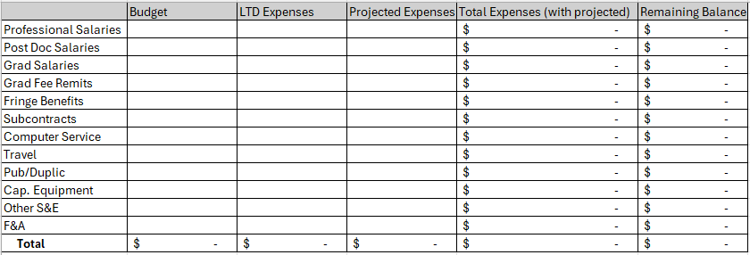

LOC:
Sponsor
Grant #
LOC Billing Type
Grant Expiration Date
External Reference
Funding Origin (DHHS only)
WBSE #
Current Income
Final Total Expense
Amount to specify (Draw/Return)
Closing Review Status

The BA will elevate to the AMA, AMM, and FM if the final invoice information is not received by the AM Invoice Prep Due Date. If the grant RCC BO doesn’t provide the necessary information by the due date to the AMA, this should be communicated to the BA and the final invoice generated based on posted expenses. The final invoice must be completed by the invoice due date but can and should be completed in a timely manner before the due date.

LOC Only – SPSAR will continue to communicate with AMA’s approaching final draw deadlines as sponsors vary month to month on dates draws are available.

BA will upload the final invoice and submission to PC.
BA will update the final invoice date in reporting requirements.
SPSAR will upload draw confirmation to PC.

Closing Checklist
Section D - Reports
Reports
Check sponsor guidelines to see what reports are required. Required reports may include: financial reports, technical reports, property reports, invention reports, MBE/WBE reports, among others. Ensure all reports listed on the Reporting Requirements tab in GMGRANT have been submitted but also check the sponsor agreement; not all reporting requirements may have been listed in SAP or in PERA for technical reporting.

The Post Award Account Management Administrator will prepare the required financial report and send the report to the Post Award Account Management Senior Manager for review and signature. The report will be returned to the Post Award Account Management Administrator for submission to the sponsor by the due date.
Note: All property, patent and financial reports must be submitted by SPS before a grant can be closed.
_____________________________________________________________________________________

Perceptive Content
Once the initial scrub is completed and the appropriate email sent to the lead business office, the checklist and email are merged and uploaded to Perceptive Content. All issues confirmed by the scrubbing will be noted in the email to the lead business office. The checklist is routed to the assigned administrator’s queue until the closing is ready to be reviewed by the area manager. When the closing is ready for review, the checklist is routed to the area manager and all closeout documentation outlined from the reporting requirements report and communication with the lead business office are uploaded in Perceptive Content. The supporting documentation should include the QTR and regulatory reports from Cognos, communication to/from business office, and any other applicable information

Closing Checklist
Section E – Budget Adjustments

Budget reductions – utilize Budget Adjustment Guide
- Final expenses for each WBSE have been verified with lead cost center.
- All steps prior to budget adjustment in closing process have been completed.
Begin with adjusting external budgets
- Adjust budget on each WBSE to match final expenses ensuring that the budget on adjusted sponsored class(es) are not less than zero after the adjustment.
- Be aware of sponsor budget restrictions (ex. Line-item overages, use of direct costs for indirect or vice versa)
- Adjust the grant value (general data tab) and information on the award data tab.

Adjusting Cost Share Budgets at Closing
- Only adjust after it has been determined that the cost share commitment was met.
- Adjusting Cost Share accounts with Balances:
  - Utilize the cost share budget template to reduce the budget to zero out the WBSE.
- Adjusting Cost Share WBSE’s with overdrafts:
  - It is the department’s decision to increase budget.
  - Charges must be allowable & within the project period.
  - Adjustments to cost share budgets must be done using the cost share budget template.

Closing Checklist
Section F- Dual Review
Closing should be dual reviewed at this time to ensure final invoicing, reporting, and budget adjustments are accurate to meet sponsor required deliverable dates.

Closing Checklist
Section G – Final Adjustments

Check Budget -Confirm budget validity end date is extended out 1 year past expiration to allow for closeout/correction entries to post.

F&A adjustment – utilize F&A Adjustment Guide
- Determine if F&A needs to be adjusted.
- Use templates provided for F&A Adjustments.

Excess Income/Overdraft
Grants must have a zero cash balance at closing. Excess income is handled as either a residual transfer or it is returned to the sponsor.
Residual transfer is an option when:
- The contract is fixed price (i.e., there is no provision for return of unexpended funds to the sponsor).
- All payments required under the contract have been received from Sponsor.
- All required project work is complete, and all reports and other deliverables have been provided to the sponsor.
- All expenses related to the project have been properly charged to the account.

Fixed Price Agreements (where the University is entitled to retain the funds)
For accounts that have unexpended funds after the end of the closeout period (all income has been received and no accounts receivable outstanding; all work, deliverables and reports have been provided; and all expenditures have properly booked to the account) and the University is entitled to retain these funds, the appropriate Post Award Closeout Funding Administrator will transfer the balance to the designated residual account in accordance with SPS Instruction No. 4
  - Once final payment has been received the Post Award Closeout Funding Administrator will request the residual account.
  - The Business Office will provide the residual account to transfer (direct cost portion).
  - If the residual account is not received 60 days after request, then the residual funds will be transferred to the grant balance adjustment account (direct cost portion).
If the unexpended balance of the grant exceeds 15% of the award amount (25% for Non-Federal sponsors) the department MUST provide an explanation why the balance exists on the residual transfer form (instruction no. 4) and have an academic signature.
If the balance is less than 15%, the use of the form is not mandatory; business office staff can email the residual account information to post-award.
Return Funds to the sponsor, verify via GR55 that the cash balance equals the amount being returned to the sponsor (see GR55 QRC).
  - AMA & AMM (approval) will provide information to Finance Team via a template (snippet below) for the return of funds.
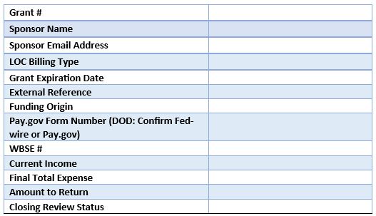

  - The SPS A/R team will prepare a ZV60 to return excess funds on non-LOC grants or LOC grants that require a check refund.
Clear Small Balance – Accounts that have a balance $100.00 or less, SPS will follow these guidelines for clearing the balance:
- The sponsor has removed the account from their letter of credit funds. Note: NSF & NIH $100 or less balances will be adjusted and returned in the letter of credit system. If the sponsor states a requirement in the agreement that all funds must be returned, then any balance will be returned.
- There is no F&A or cost shown on the account to adjust in closing.
- Non letter of credit sponsors must be contacted to determine if they want the amount refunded. If yes, the balance must be refunded.
- If the sponsor does not want the balance refunded, the balance will be cleared via a Journal Voucher (FV50)
All balances over $100.00 will be returned to the sponsor unless it is a Fixed Price Agreement.

Clear Small Overdraft -
- Departments should target clearing the overdraft as close to a zero balance as possible. Grants that have a small overdraft of $100.00 or less and have no funds remaining will be cleared to account 320002199.. Note: Overdraft grants in excess of $100.00 will be cleared by the academic department.
Note: If F&A is applicable on the grant, the relevant F&A should be removed via template entry and then clear the remaining overdraft direct cost balance to the grant balance adjustment account. Both entries should be completed by the AMA at the same time.

Closing Checklist
Section H - Grant Finale

- Run Final Cognos Closing Report and print to Perceptive Content as part of Final Closeout Documentation
- Check grant reporting requirements and update completion dates
- Verify FSSR – verify there are no outstanding account receivables and income should equal total sponsor expense which should equal budget. Confirm the FSSR reflects a zero grant
- Verify GR55
- Verify termination section in SAP – If the grant is closing due to a termination, ensure termination type in SAP is updated and any associated comments are added.
- Revenue Allocation - Verify all revenue has been allocated according to expenses on each WBSE account (excluding Cost Share WBSE’s). If not, allocate revenue as necessary by a JV document
- Cost Share Revenue – Verify all revenue has been allocated to the Cost Share accounts as part of the C/S budgeting entries

Closing Checklist
Section I – Grant Closeout
- Enter storage dates in SAP
- Reviewer of final closeout needs to change status in SAP to Closed/Closed.

Any updates completed after the Closing Checklist is uploaded can be documented using the sticky notes within Perceptive Content

Final Closeout
Once the closeout is completed, the expired/expiring report should be monitored monthly. It is important to review and analyze what additional steps are needed to ensure the final close of the grant is done timely. Continue to work with business offices based on their responses. Any pending charges, pending residual, charges removed or added should be addressed with the lead business office and business manager. They should be given 30 days to respond.
If no response after 30 days and charges were removed:
- Second email will be sent to the lead business office, business manager and DFA while copying the area manager. If no response is received the email confirms a refund will be issued to the sponsor. Closing documents will be revised and resubmitted as required.
If no response after 30 days and charges were added:
- Second email will be sent to the lead business office, business manager and DFA while copying your area manager.
If no response after 30 days (60 days overall):
- Third email will be sent to the lead business office, business manager, DFA, area manager and Post Award Director. Continued monitoring to ensure charges are removed.
If no response after 30 days and charges are pending:
- Second email will be sent to the lead business office, business manager and DFA while copying the area manager.
If no response after 30 days (60 days overall) and charges are pending:
- Third email will be sent to the lead business office, business manager, DFA, area manager and Post Award Director. The grant will be closed out based on current expenses and no further charges will be allowed on the grant.
If no response after 30 days and there is a residual:
- Second email will be sent to the lead business office, business manager and DFA while copying the area manager.
If no response is received after 30 days (60 days overall) and a residual is pending:
- The residual amount (direct cost portion) will be transferred to the grant balance adjustment account as noted in Section G – Fixed Price Agreements.
Once all income has been received and there are no other pending items to address, the checklist can be routed to your manager. SAP status should be changed to closed/closed with appropriate storage dates entered. Perceptive Content status should be changed to closed.
- Verify GR55 – Confirm the cash balance, other assets (AR), and Liabilities are zero
- Enter Storage and destroy date on Additional Reference Tab in GMGRANT
  - Date to Storage = 4/1/xx or 10/1/xx
  - Date to Destroy = Date to Storage + 3 years
- Change status in SAP to Closed/Closed
- Update Closing status in Perceptive Content on the Closing Checklist document type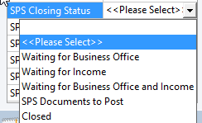

Status Updates in SAP
Make sure to keep or update your grant status based on the following:
Expired status – Pending items such as overdrafts, commitments, GR/IR
SPS Closed – Only waiting on Income
Closed/Closed – All income received, no commitments, overdrafts, or GR/IR.

Tips and Tricks

Use the Closing checklist generated out of the BI. Upload the entire document to the grant file in Perceptive Content.

It is recommended that we will not need to image documents that can be replicated, such as the FSSR, JV’s and ZV60’s.

We will need to image all closing documents that cannot be replicated such as emails, copies of refund checks with letters and any other information gathered in the closing process.

The Billing Administrator will image Final invoices.

Final reports will be imaged using the SPS Reports document type.

Please do not upload the closing documents with the Closing Checklist as this is a routable document. Those types of documents should be merged and uploaded as SPS Closing Documents

